Implementation of Standard Operating Procedures (SOP)

- Exit plan displayed at various places in the school building.
- Mock drills conducted.

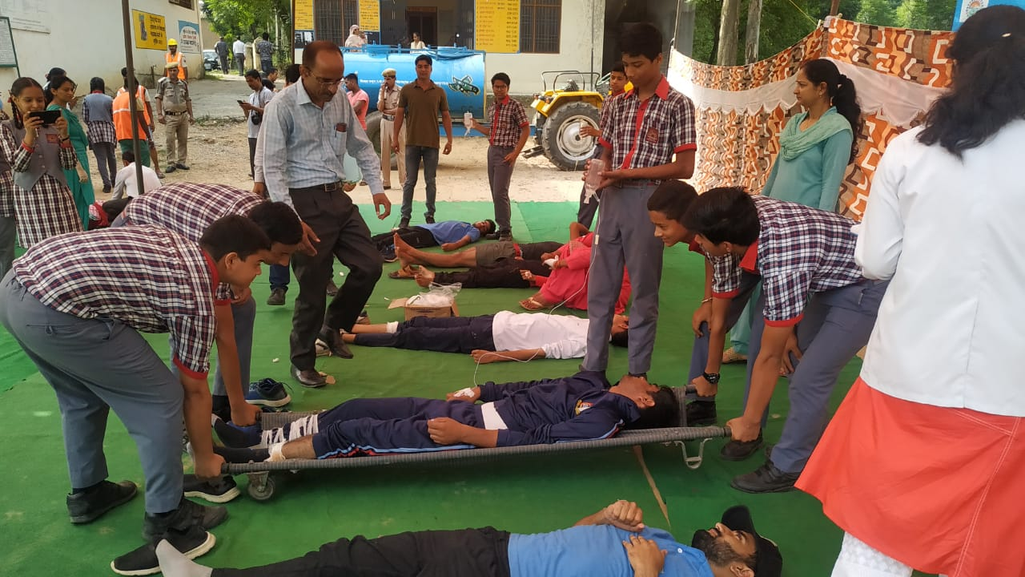

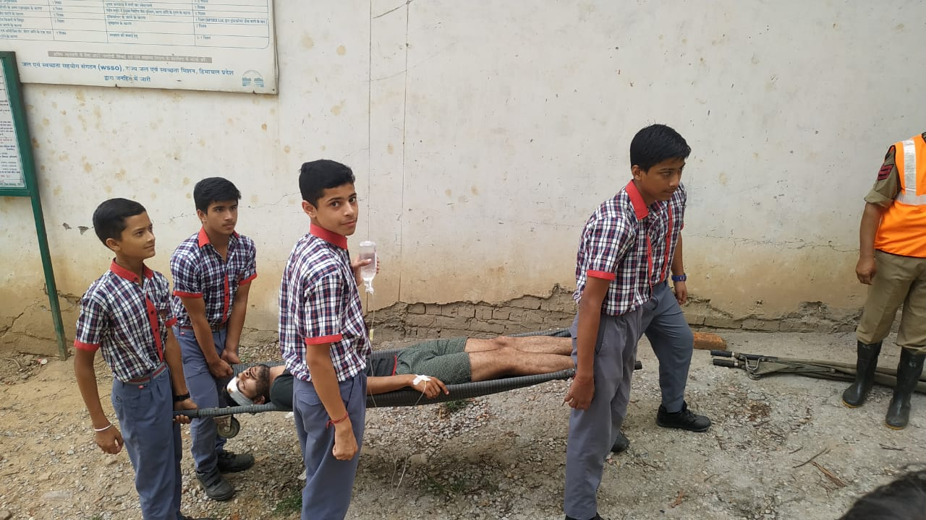
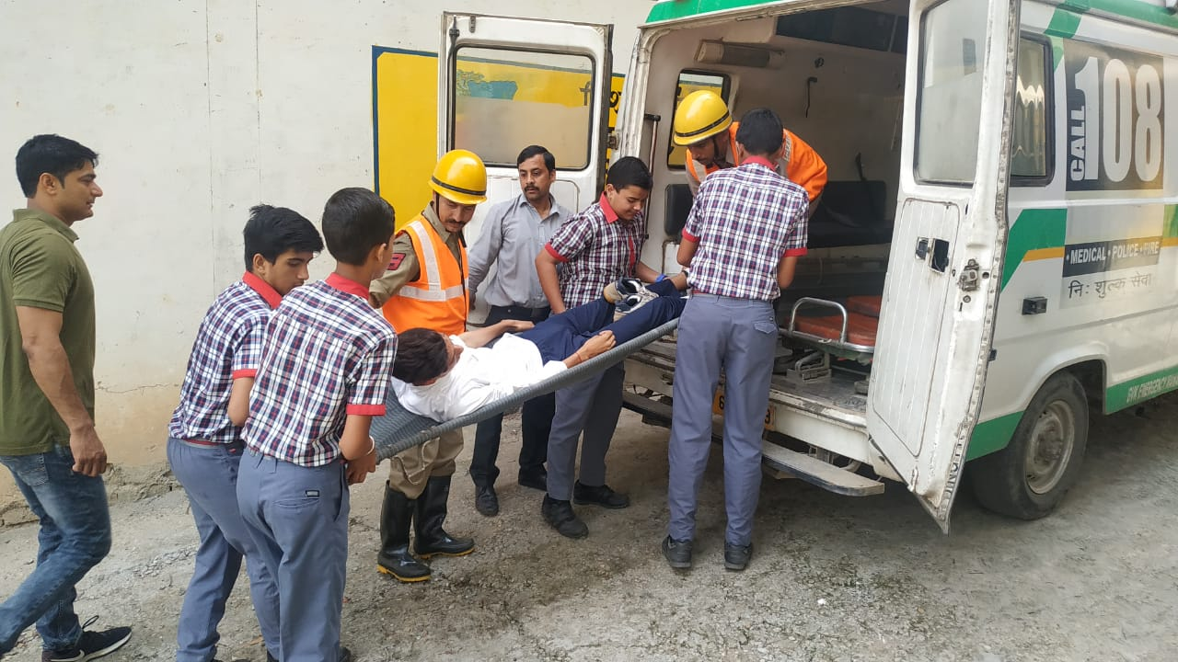

MOCK DRILLS

